Milestone 6: 2/7/2021 – 9/7/2021

This sprint was a bit shorter, but everything got done.

|  |  |  |
| --- | --- | --- |
| Goal | Description | To Deliver |
| Hold “getting back to it” meeting. | Hold the meeting. | Hold the meeting. |
| Get to know the project again | It’s been a while. Use the other goals as a chance to remember how everything is done. |  |
| Start designing enemy types | There should be some different enemy types to help teach the player how to use their skills. Design them. | At least 1 enemy type fully conceptualised. Possibly work towards making them. |
| Implement room #1 | Room #1 is pretty barren by design, so should be an easy beginning point for getting back into it. | Room #1 is a corridor. The Helper is there and gives some dialogue. The player should also have a tutorial on how to attack (no more complicated than Hollow Knight). |
|  |  |  |

Milestone 7: 19/7/2021 – 30/7/2021

A two week time frame on this one, as life is becoming more stable and Liam is able to dedicate more time to work. However, Liam will have a full week of tutorials from the 26th to the 30th, so best to keep expectations low for the amount of work that can be done as Liam feels out how much he can do in a week.

|  |  |  |
| --- | --- | --- |
| Goal | Description | To Deliver |
| Hold Milestone meeting | Hold the meeting. | Hold the meeting. |
| Fix bugs | Bugs that have been found:   * Errors when attacking the rock. These can cause Unity to freeze. * Getting stuck on the floor while moving in Room 1. | Fix the bugs so they do not occur again. |
| Implement Lost Shade enemy | The Lost Shade has two behaviours:   * Patrol their platform, walking back and forth. * When they see the player, they rush forwards, increasing their speed and shrieking. * They die in one hit. |  |
| Implement Canon enemies | Canon enemies:   * Stay still * Shoot periodically. |  |
| Art: Create sprites for the enemies | As detailed below, each enemy type needs to have its sprites |  |
| Design Room 2 | Room 2 is a winding platforming challenge leading upwards, with platforms and enemies. Design the |  |

Enemy ideas:

* Lost Shades: (the ones from last week)
  + Behaviour
    - Rush the player when they see them.
    - Enemies pace back and forth along their platform, then get a speed boost as they charge towards the player.
  + Sprites and animations:
    - Moving (left and right)
    - Charging (racing forward, perhaps clawing their way faster towards the player?)
    - Dying (slashed with sword)
* Cannon enemies
  + Like Octorocks, they shoot balls at the player.
  + The balls can be deflected.
  + These enemies do not move, they are completely stationary.
  + Sprites and Animations:
    - Neutral
    - Shooting
    - Canonball sprite

First Level:

* Idea:
  + Introductory
  + Teaches the player how to play
  + Some smaller challenges
  + Tutorial character – teaches you how to play while adding personality
* Obstacle ideas:
  + Platforming – not many platforming abilities, should not be the main focus?
  + Shade-gate (Hollow Knight) – a gate that stops progress unless you dash through them.
  + Enemies – teach you how to block/parry/dash/jump over obstacles

Idea:

* The game is a cycle from the beginning of the game to the end – boss kills you, you begin again beneath the arena, start over.
* The characters mention this right from the beginning – you’ve done this before
* “Back again so soon?”
* Characters are aware of how many times you’ve died (e.g. through a singleton script that takes note of all the things you’ve done in the game)

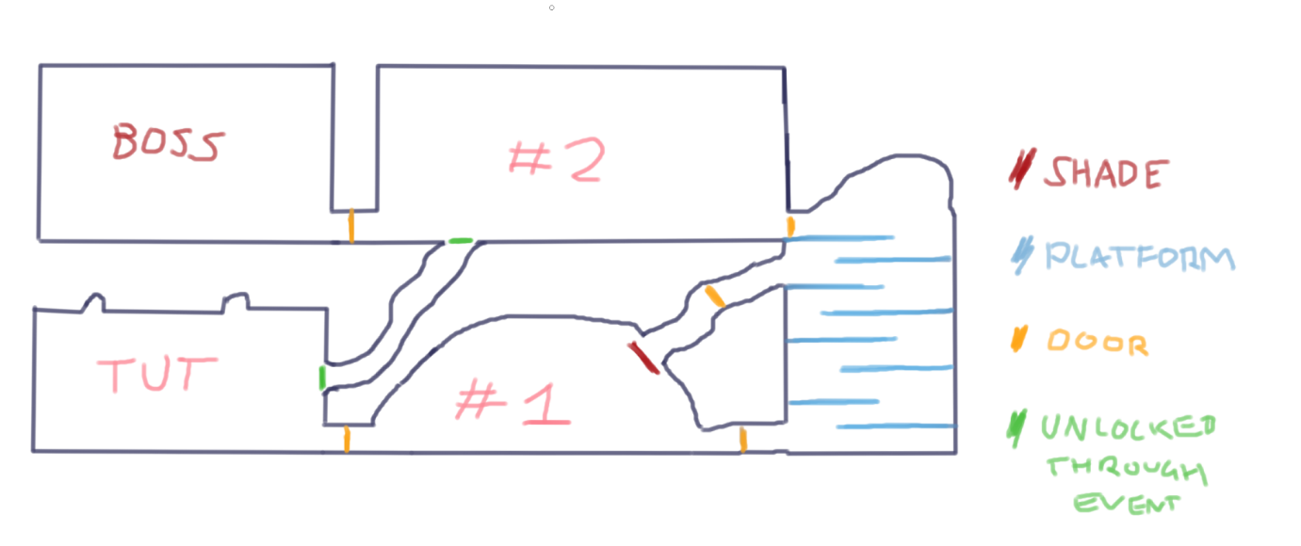

Tut = player spawn. Meets the Prisoner

#1 = Player meets the Helper

Then platforming/fighting section.

#2 = just outside the throne room. Within the palace

Boss = throne room